**ITT575 - Android Lab  
Muhammad Shafiq Bin Ahmad Razman  
2017724867  
CS245-6A**

Section 1: Turn on and off WIFI connection on Android app

When WIFI is currently on, switch checked = true, Turn OFF text.

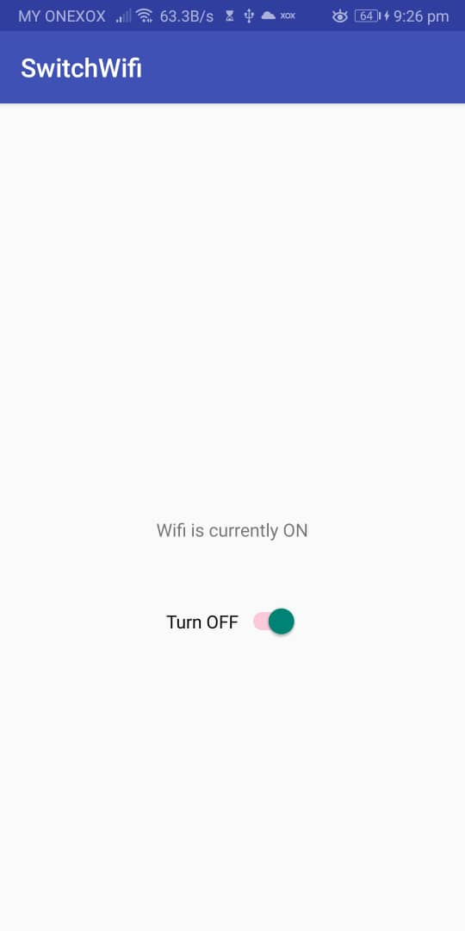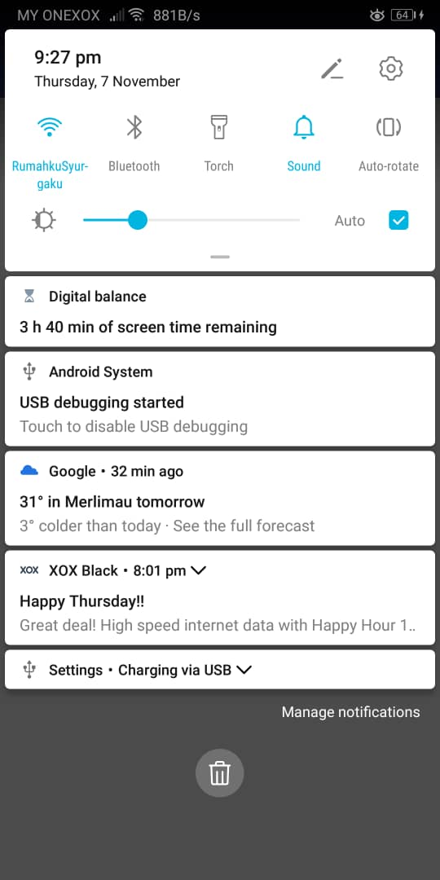

When switch is toggled, WIFI is currently off, switch checked = false, Turn ON text.

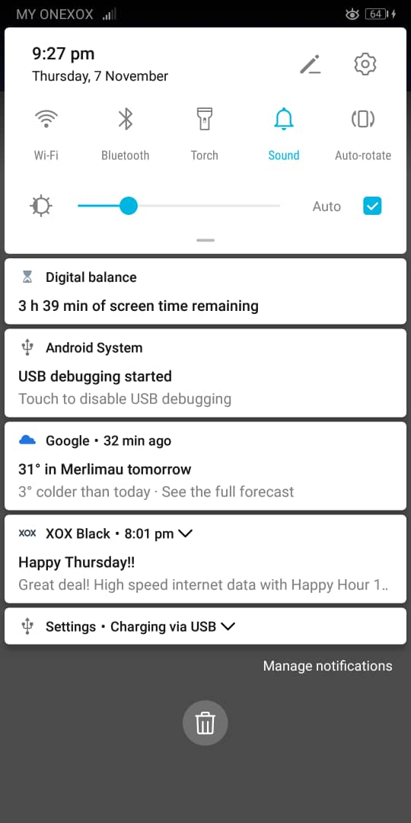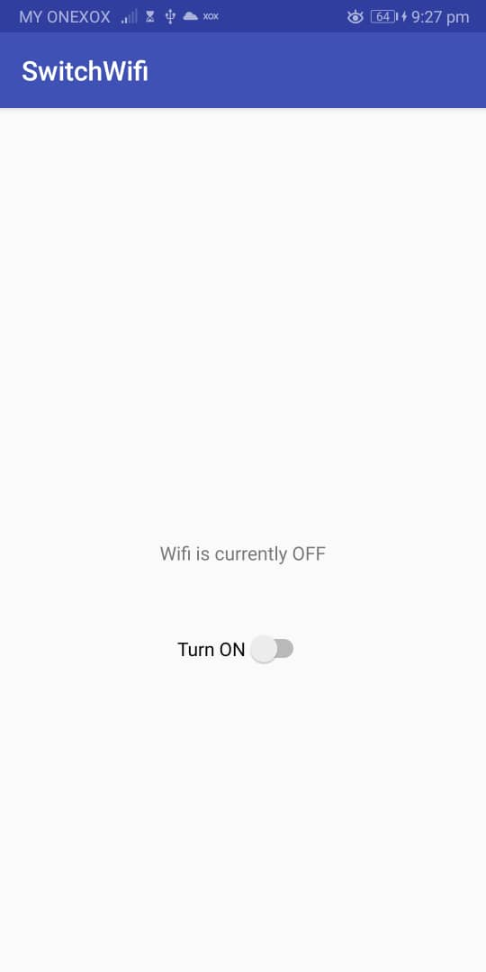

Section 2: Get IP and MAC address



When the button is clicked, the information (IP and MAC) appears.

Source code:

Section 1: <https://github.com/shafiq97/ITT575AndroidLabSwitchWifiOnOff>

Section 2: <https://github.com/shafiq97/ITT575AndroidLabGetIPMAC>